Blackwoods Scenic Byway
Hancock County Planning Commission
395 State Street, Ellsworth, ME 04605
(207) 667-7131 / (207) 667-2099 (fax)
Info@blackwoodsbyway.org / www.blackwoodsbyway.org
David Cole, Commissioner
Maine Department of Transportation
16 State House Station
Augusta, ME 04333-0016

October 3, 2008

David Cole:

This letter, co-signed by the Towns of Franklin and Cherryfield, requests that MaineDOT extend byway designation of the Blackwoods State Scenic Byway:
- West 7.9 miles from Township 9 SD along Route 182 through the Town of Franklin to the Hancock town line, and
- 1.3 miles east from the Cherryfield crossing of Route 182 and the Calais Branch Rail corridor along on Route 182 and Route 1 to the Milbridge Town Line. (See attached map.)

The Blackwoods Scenic Byway was first designated in the 1971, and was identified as one of Maine’s most scenic backcountry roads, crossing under a canopy of trees and visiting clear lakes and rocky topped mountains. In 2004 the first corridor Management Plan was adopted by the corridor management committee and recognized in the Cherryfield Comprehensive Plan. The corridor plan, which is posted online at www.blackwoodsbyway.org, incorporated the historic villages and scenic views in Franklin and Cherryfield, which serve as cultural bookends to this unique scenic byway.

The Blackwoods Byway Corridor Committee and the elected town leaders of Cherryfield and Franklin support extending byway designation for several practical reasons.

- The current designation starts and ends in remote rural locations, without a sense of arrival,
- Transforming this byway from 12.5 miles to 21.7 miles extends the visitor’s experience, providing more opportunities to find interesting educational and recreational activities,
- The towns provide a rustic cultural context that accounts for the creation of the byway and continue to serve it with small shops, bed and breakfasts, campgrounds and other visitor amenities,
- Visitors are excited to learn about Franklin and Cherryfield, with their historic architecture and cultural activities,
- The Down East Sunrise Trail, an interim use of the Calais Branch rail corridor crosses Route 182 in Franklin and Cherryfield. Extending designation to include both crossings and the nearby villages will increase interest in both corridors.
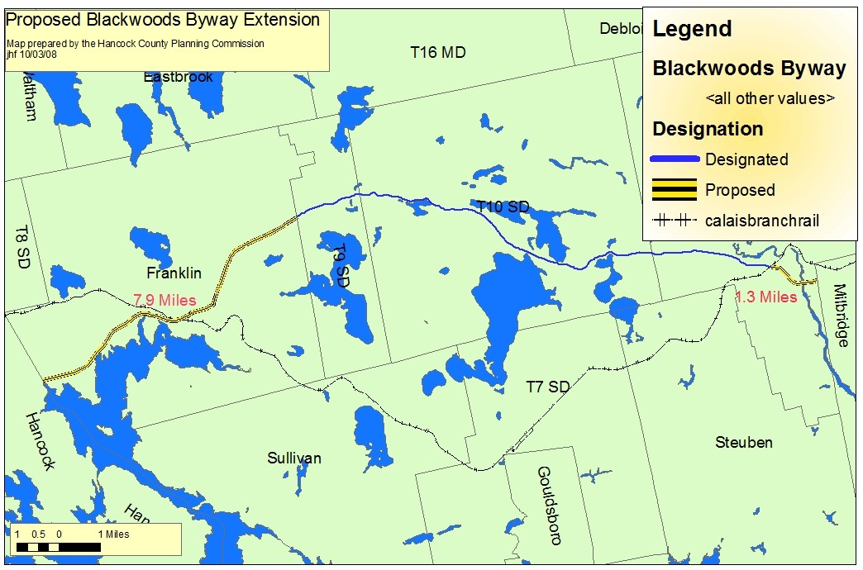

- There are few residents along the currently designated byway. Including Franklin and the village center of Cherryfield will encourage greater community involvement,
- The Towns of Cherryfield and Franklin offer new opportunities for partnerships for byway enhancement projects, including historic interpretation, village beautification and economic development.

Because the adopted Corridor Management Plan fully incorporates these extensions, we feel that very little additional effort will be required to extend state scenic byway designation. Your support and staff support from the Maine Department of Transportation, the Hancock County Planning Commission and the Washington County Council of Governments can implement this extension using funds that are already in hand.

Thank you for your consideration,

Sincerely,

_________________________ ________________________

Town of Franklin, Maine Town of Cherryfield, Maine

